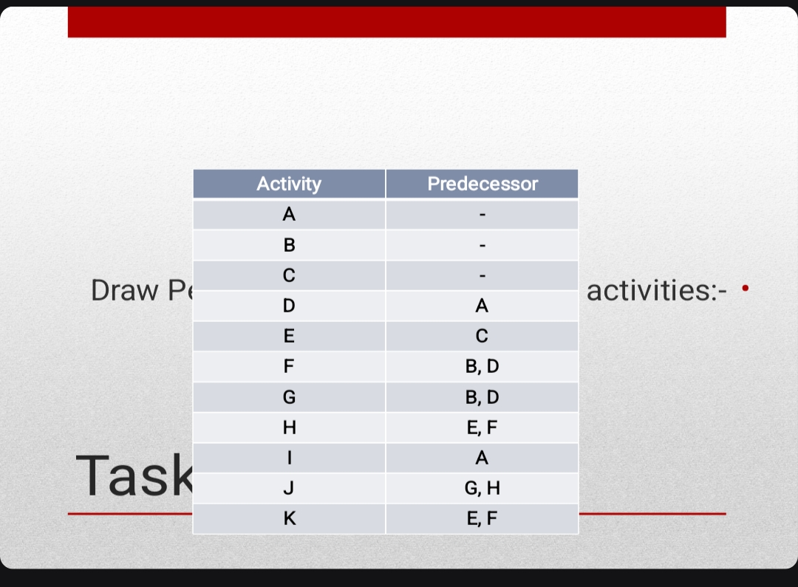

I
10
A
B D
1
5
4
9
C
7
3
G
F
8
E
H J
2

K

